WANT TO BE A HIGH FLYER?

We celebrate the Wright brothers as the founding fathers of manned flight but it may surprise some to learn that the development of their first aeroplane, ‘The Wright Flyer’, that first flew in December 1903, relied heavily upon the brothers’ development of home-built model gliders to refine their flying machines.

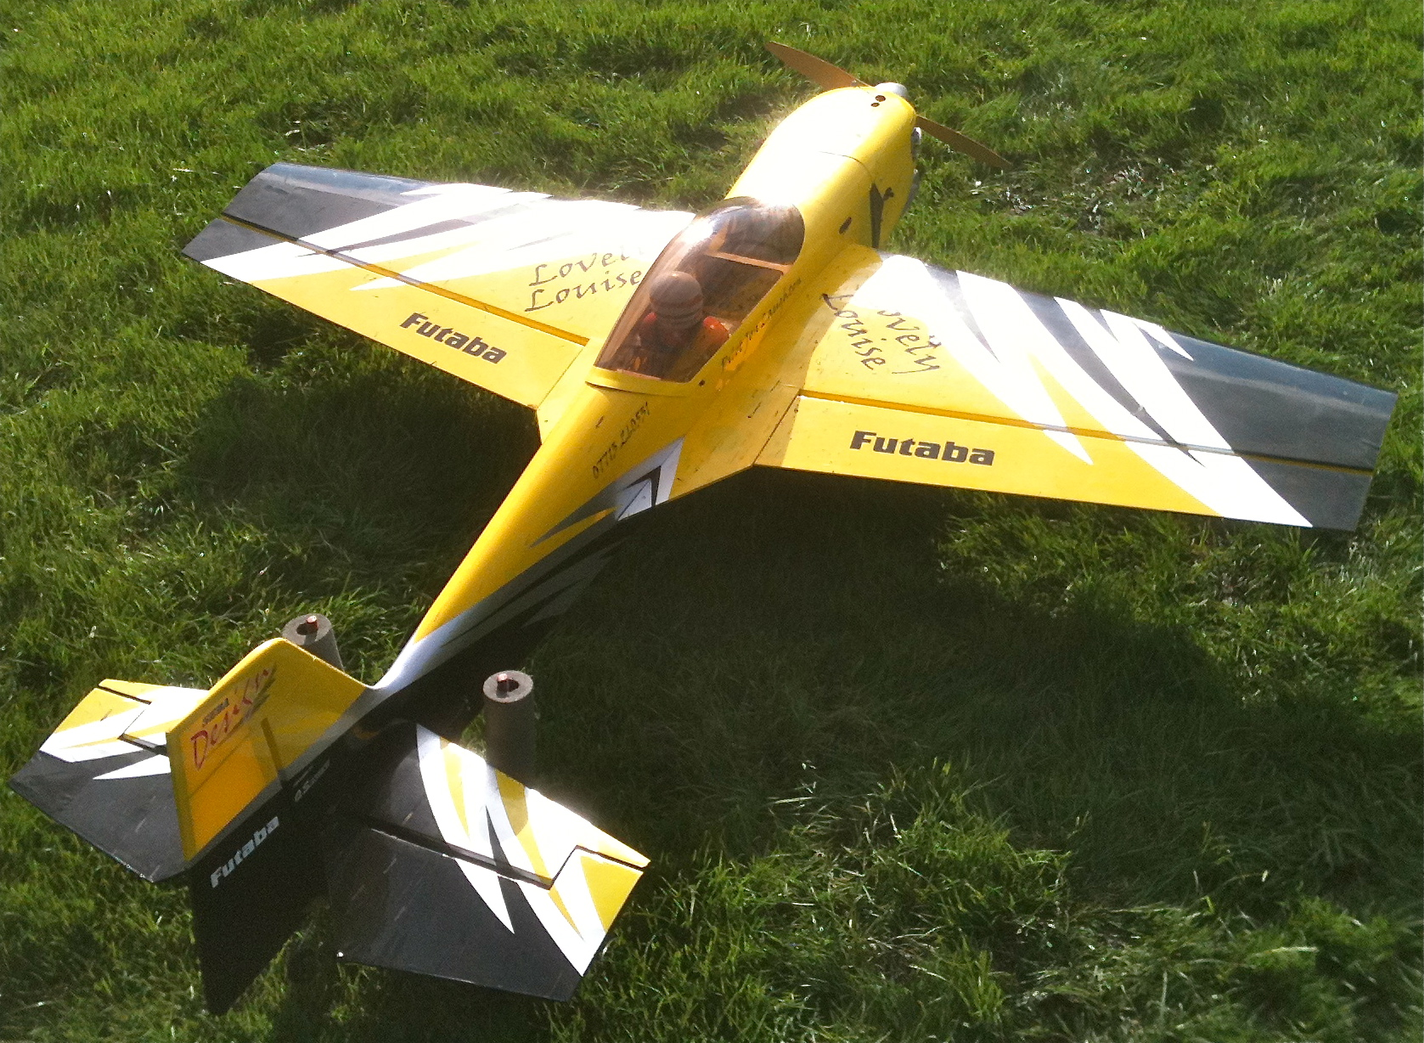
Fast forward 111 years and the flying of model aeroplanes is still something that enthrals enthusiasts. Of course today’s technology available would have been unimaginable to Orville & Wilbur, although they would recognise some of the basic construction methods that still use balsa wood, glue and fabric coverings. Today these materials are supplemented by carbon fibre, foams, aluminium alloys, sophisticated electric motors, powerful battery technology that evolved from mobile phones, heat shrink plastics and small internal combustion engines that deliver a lot of power for not very much weight.

Digital electronics development has meant the radio transmitters used today to fly model aeroplanes are lightweight, reliable and safe, meaning it is now easier than ever to enjoy this fabulous hobby.

For those growing up in the 1950s to 1970s, enthused by a British aerospace industry that led the world, radio control aeroplanes were something that only a few dared to dream about as the costs were prohibitive and the technology unreliable. Now the costs of this hobby compare favourably to computer games consoles and other IT gadgets..

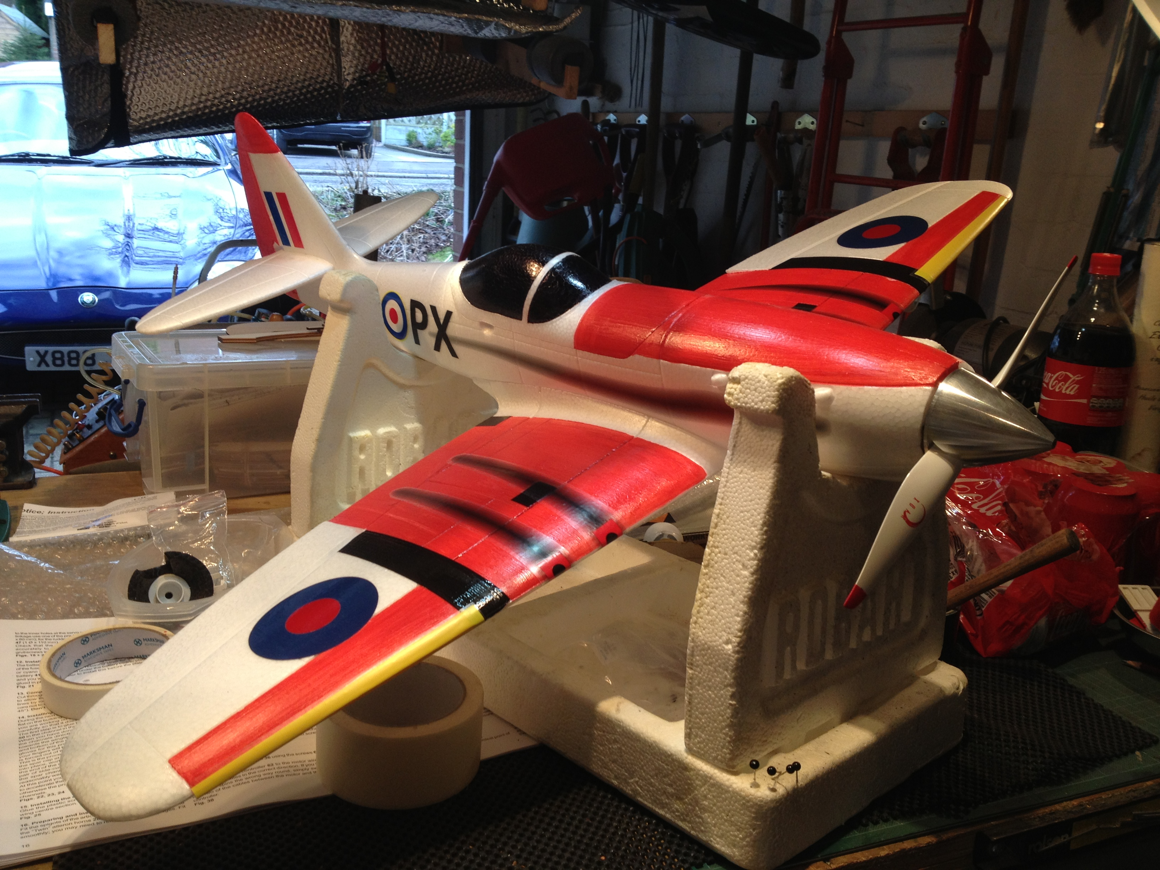
Flying is only a part of the hobby – building a model aeroplane can be as simple as bolting some parts together and installing electronics or it can be much more complicated requiring parts to be individually cut from balsa or ply wood and assembled in much the same way as a full size aeroplane. It is therefore not surprising that many of the people who work in the modern aerospace industry have had some involvement with remote control flying models.

Radio controlled aeroplanes or helicopters are often dismissed as ‘big boys toys’! In reality it requires careful preparation to put a model into the air safely and to be able to bring it back to earth in one piece but the sense of achievement can’t be beaten and the public are not aware that this sport / hobby is actually controlled by the Civil Aviation Authority….

So why not fulfil your dreams and have a go on a trainer model with Oldham & District Model Flying Club?

Contact us at www.oldham-mac.co.uk

